TRAFFIC SHAPING ALGORITHMS IN C
- Leaky Bucket Algorithm C Program (leaky_bucket.c):
Code:
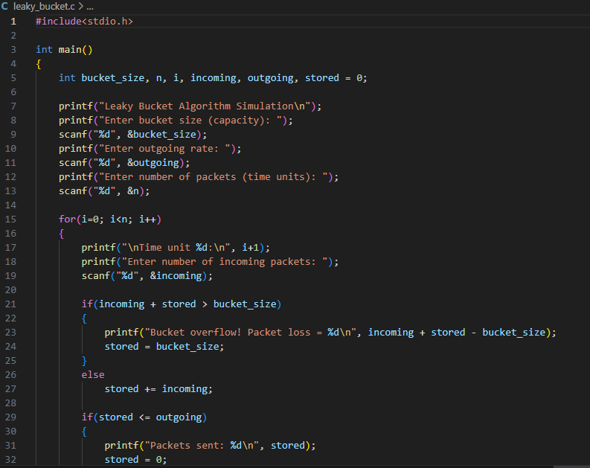

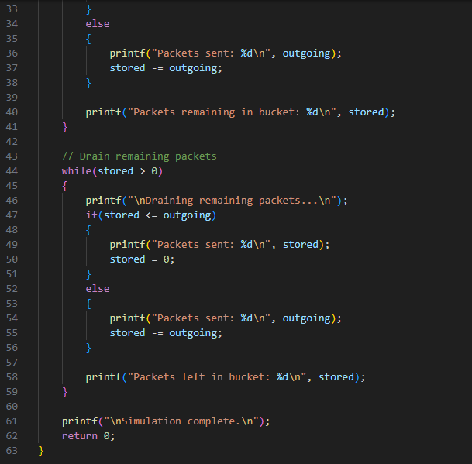
Output:
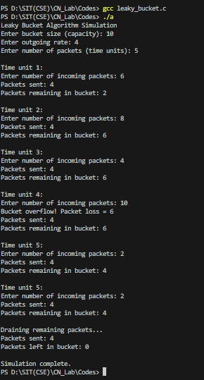

- Token Bucket Algorithm C Program (token_bucket.c):
Code:
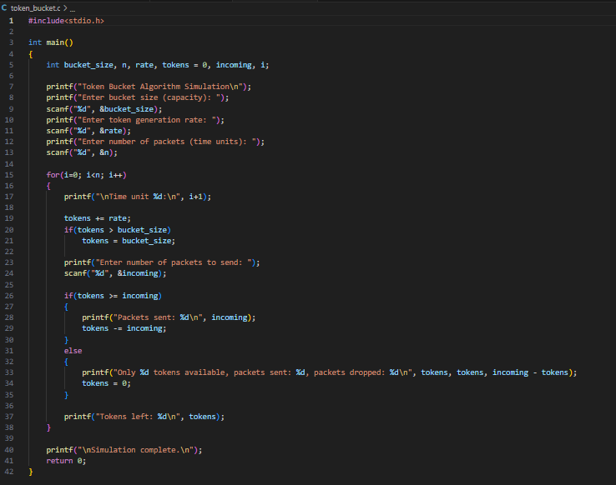

Output:



